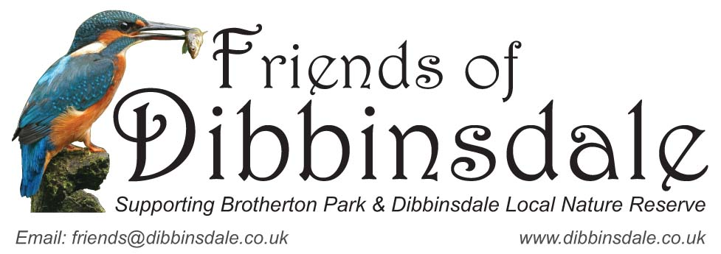

Membership Form
Brotherton Park and Dibbinsdale Local Nature Reserve extend over 130 acres along the River Dibbin valley. It has many different wildlife habitats. These include ancient woodland, a river valley with willow carr, reed beds and meadows. It is also a site of special scientific interest (SSSI). There are numerous walks and a Visitor Centre, it is a real joy for all the family combined with easy access and an onsite car park. It is managed by Wirral Council.
The Friends of Dibbinsdale is a registered charity for people with an interest in the park. Some volunteer and help the ranger, others lend their support by sharing our interests in the wildlife, photography, countryside crafts and joining in our activities. The Friends of Dibbinsdale is well supported by the local Ranger Service.
If you are interested in joining and receiving our emailed newsletter about activities in and around the reserve please fill in the application below:
Name ..............................................................
Address ..............................................................
..............................................................
..............................................................
Postcode ........................... Tel. Number ...................................
E-mail .....................................................................
Membership is FREE. However if you wish to make an optional, affordable donation, either small or large, cash and cheques can be sent to the address below or donate via PayPal in the 'About Us' section on our website at www.dibbinsdale.co.uk
Please return this form with subscription to:
Friends of Dibbinsdale
c/o Rangers Office
Dibbinsdale Local Nature Reserve
Woodslee Cottages
Spital Road
Bromborough
Wirral
CH62 2BJ

