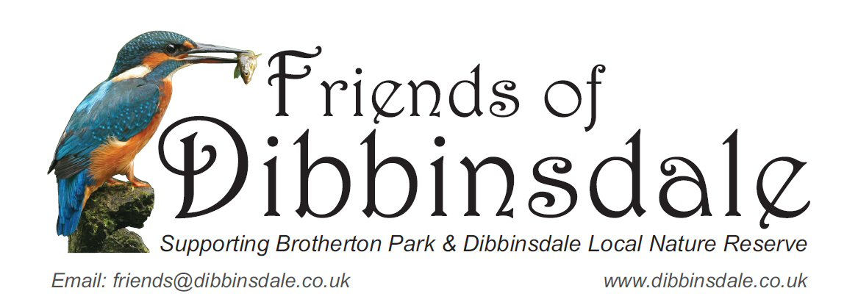

Friends of Dibbinsdale

Privacy Statement

In Compliance with General Data Protection Regulations 2018
The Friends of Dibbinsdale (Registered Charity Number 1039303) promise to respect the confidentiality of any personal data you share with us and we will always take every effort to protect your privacy.
We pride ourselves on our honesty and openness and will always be clear how, when and why we collect and process your information; we promise we will never do anything with your details that you wouldn’t reasonably expect.
This privacy statement explains how this Friends group will use any personal information we collect about you for running the charity, received both online and offline, as well as any electronic, written or oral communication.
WHAT INFORMATION DO WE COLLECT?
We collect information about you when you join the Friends of Dibbinsdale. The information we collect about you will include your name, and email address. Other information such as home address, telephone number and personal information will not be collected or stored routinely. Any information will be stored in an electronic file protected by appropriate security measures e.g. password protection and firewall.
If however there is a specific reason for collecting this additional information it will be specified in the appropriate Privacy Notice. Such data will not be retained beyond the termination of the specific reason. Such persons to be included in this category include, Trustees (information required by Charity Commission), Chairman , Treasurer and Secretary for whom information is required for managing the charities bank accounts and making purchases.
HOW DO WE USE THE INFORMATION ABOUT YOU?
We collect information about you to enable us to contact you and ensure the smooth running of the Charity and for welfare reasons as necessary.
This may include creating a record in your name on our event/competition system to record your relevant information and track payment of entry fee or any sponsorship money.
Gift Aid - at present we do not ask for any donations to be Gift Aided. If at some future time this does become a possibility, and if instructed by you ,we would then be required to collect the necessary information to report your donation to HM Revenue and Customs (HMRC) for Gift Aid collection.
WHO WILL USE YOUR PERSONAL INFORMATION?
The club organiser will hold and maintain the date for the safe running of the event. Information will only be shared with those that “need to know” the information at the appropriate time. E.g. If an event is organised by the Friends group, then the event organiser will hold and maintain the data required for the safe running of the event.
ACCESS TO YOUR INFORMATION AND CORRECTION
We want to ensure that your personal information is accurate and up to date. Please contact us to correct information you think is inaccurate.
HOW LONG WILL MY INFORMATION BE HELD?
The information will only be retained safely whilst you remain a Friend of Dibbinsdale. We are only legally able to retain information if we can justify it for reasons specified in this notice.
Any Gift Aid information will be held in accordance with the HM Revenue and Customs (HMRC) guidelines for financial records and auditing purposes and for as long as required to administer your donations and any subsequent queries.
MARKETING
We will not sell, trade or share your personal information with third parties unless you give us specific permission to do so. e.g. passing your email address onto another local 'Friends' group.
CHANGES TO OUR PRIVACY STATEMENT
We keep our privacy statement under regular review.
PRIVACY STATEMENT LINKS
Friends of Dibbinsdale website www.dibbinsdale.co.uk
Charity Commission website https://www.gov.uk/government/organisations/charity-commission
HOW TO CONTACT US
Please contact us if you have any questions about our privacy statement or information we hold about you:
- By email: friends@dibbinsdale.co.uk
- By telephone: Please message via Ranger's Office 0151 334 9851
- Or write to us at:
The Ranger’s Office
Dibbinsdale LNR
Woodslee Cottages
Spital Road
Bromborough
Wirral
Merseyside
CH62 2BJ
RDW May 2018

